**AIM: Program to simulate star topology.**

**THEORY:**

**Understanding Network Topology:**

Network topology is the arrangement of the elements (links, nodes, etc.) of a communication network. Network topology can be used to define or describe the arrangement of various types of telecommunication networks, including command and control radio networks, industrial field busses and computer networks.

Network topology is the topological structure of a network and may be depicted physically or logically. It is an application of graph theory wherein communicating devices are modelled as nodes and the connections between the devices are modelled as links or lines between the nodes.

Physical topology is the placement of the various components of a network (e.g., device location and cable installation), while logical topology illustrates how data flows within a network. Distances between nodes, physical interconnections, transmission rates, or signal types may differ between two different networks, yet their logical topologies may be identical.

A network’s physical topology is a particular concern of the physical layer of the OSI model.

Examples of network topologies are found in local area networks (LAN), a common computer network installation. Any given node in the LAN has one or more physical links to other devices in the network; graphically mapping these links results in a geometric shape that can be used to describe the physical topology of the network.

A wide variety of physical topologies have been used in LANs, including ring, bus, mesh and star. Conversely, mapping the data flow between the components determines the logical topology of the network. In comparison, Controller Area Networks, common in vehicles, are primarily distributed control system networks of one or more controllers interconnected with sensors and actuators over, invariably, a physical bus topology.

**Star Topology:**

Star topology is a network topology where each individual piece of a network is attached to a central node (often called a hub or switch). The attachment of these network pieces to the central component is visually represented in a form similar to a star.

Star topology is also known as a star network.

Star topologies are either active or passive networks, depending on the following:

* If the central node performs processes, such as data amplification or regeneration
* If the network actively controls data transit
* If the network requires electrical power sources.

Star topologies also may be implemented with Ethernet/cabled structures, wireless routers and/or other components. In many cases, the central hub is the server, and the additional nodes are clients.

**Benefits of a star network topology include the following:**

* Has the ability to limit the impact of a single failure. In star networks, a single unit is isolated by its relationship to the central hub, so that if a component goes down, it only affects that unit's local reach.
* Facilitates adding or removing individual components to and from a network, for the same reasons.

**Disadvantages of star topology:**

* May have a higher cost to implement, especially when using a switch or router as the central network device.
* The central network device determines the performance and number of nodes the network can handle.
* If the central computer, hub, or switch fails, the entire network goes down and all computers are disconnected from the network.

**SOURCE CODE:**

#include "ns3/core-module.h"

 #include "ns3/network-module.h"

 #include "ns3/netanim-module.h"

 #include "ns3/internet-module.h"

 #include "ns3/point-to-point-module.h"

 #include "ns3/applications-module.h"

 #include "ns3/point-to-point-layout-module.h"

 using namespace ns3;

 NS_LOG_COMPONENT_DEFINE ("Star");

 int main (int argc, char *argv[])

 {

  // Set up some default values for the simulation.

 Config::SetDefault ("ns3::OnOffApplication::PacketSize", UintegerValue (137));

  // ??? try and stick 15kb/s into the data rate

 Config::SetDefault ("ns3::OnOffApplication::DataRate", StringValue ("14kb/s"));

// Default number of nodes in the star. Overridable by command line argument.

   uint32_t nSpokes = 8;

  CommandLine cmd;

  cmd.AddValue ("nSpokes", "Number of nodes to place in the star", nSpokes);

  cmd.Parse (argc, argv);

  NS_LOG_INFO ("Build star topology.");

  PointToPointHelper pointToPoint;

  pointToPoint.SetDeviceAttribute ("DataRate", StringValue ("5Mbps"));

  pointToPoint.SetChannelAttribute ("Delay", StringValue ("2ms"));

  PointToPointStarHelper star (nSpokes, pointToPoint);

// Create a PointToPointStarHelper in order to easily create star topologies using p2p links.

  NS_LOG_INFO ("Install internet stack on all nodes.");

  InternetStackHelper internet;

  star.InstallStack (internet);

  NS_LOG_INFO ("Assign IP Addresses.");

  star.AssignIpv4Addresses (Ipv4AddressHelper ("10.1.1.0", "255.255.255.0"));

  NS_LOG_INFO ("Create applications.");

  //

// Create a packet sink on the star "hub" to receive packets.

  //

  uint16_t port = 50000;

  Address hubLocalAddress (InetSocketAddress (Ipv4Address::GetAny (), port));

  PacketSinkHelper packetSinkHelper ("ns3::TcpSocketFactory", hubLocalAddress);

  ApplicationContainer hubApp = packetSinkHelper.Install (star.GetHub ());

  hubApp.Start (Seconds (1.0));

  hubApp.Stop (Seconds (10.0));

// A network socket is a software structure within a network node of a computer network that serves as an endpoint for sending and receiving data across the network.

// PacketSinkHelper -Receive and consume traffic generated to an IP address and port.

//

  // Create OnOff applications to send TCP to the hub, one on each spoke node.

  //

  OnOffHelper onOffHelper ("ns3::TcpSocketFactory", Address ());

  onOffHelper.SetAttribute ("OnTime", StringValue ("ns3::ConstantRandomVariable[Constant=1]"));

  onOffHelper.SetAttribute ("OffTime", StringValue ("ns3::ConstantRandomVariable[Constant=0]"));

  ApplicationContainer spokeApps;

  for (uint32_t i = 0; i < star.SpokeCount (); ++i)

  {

  AddressValue remoteAddress (InetSocketAddress (star.GetHubIpv4Address (i), port));

  onOffHelper.SetAttribute ("Remote", remoteAddress);

  spokeApps.Add (onOffHelper.Install (star.GetSpokeNode (i)));

  }

  spokeApps.Start (Seconds (1.0));

  spokeApps.Stop (Seconds (10.0));

    NS_LOG_INFO ("Enable static global routing.");

  //

  // Turn on global static routing so we can actually be routed across the star.

    Ipv4GlobalRoutingHelper::PopulateRoutingTables ();

  NS_LOG_INFO ("Enable pcap tracing.");

//

  // Do pcap tracing on all point-to-point devices on all nodes.

  //

  pointToPoint.EnablePcapAll ("narenderStar");

  NS_LOG_INFO ("Run Simulation.");

  star.BoundingBox(1,1,100,100);

  AnimationInterface anim("narenderStarAnim.xml");

  Simulator::Run ();

  Simulator::Destroy ();

  NS_LOG_INFO ("Done.");

  return 0;

 }

**OUTPUT:**

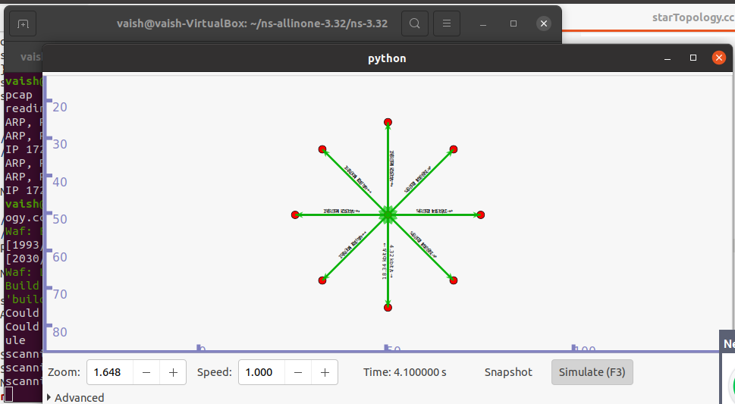

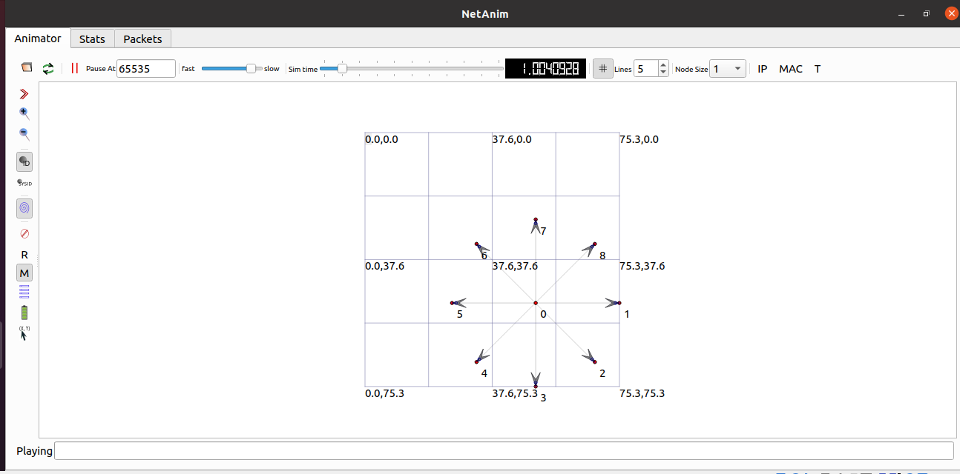

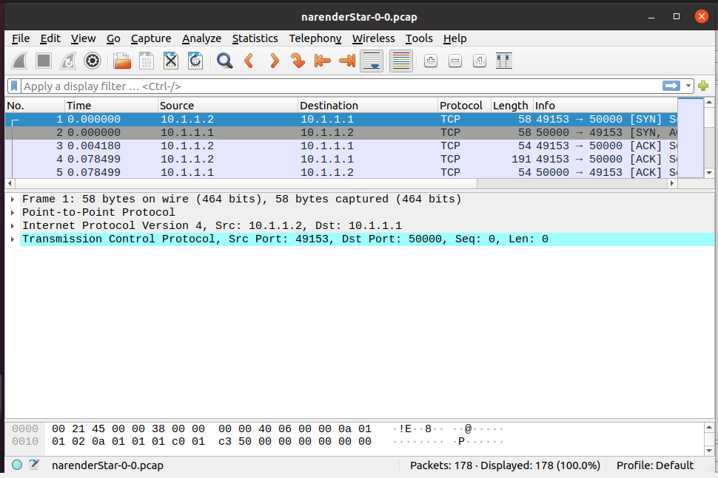

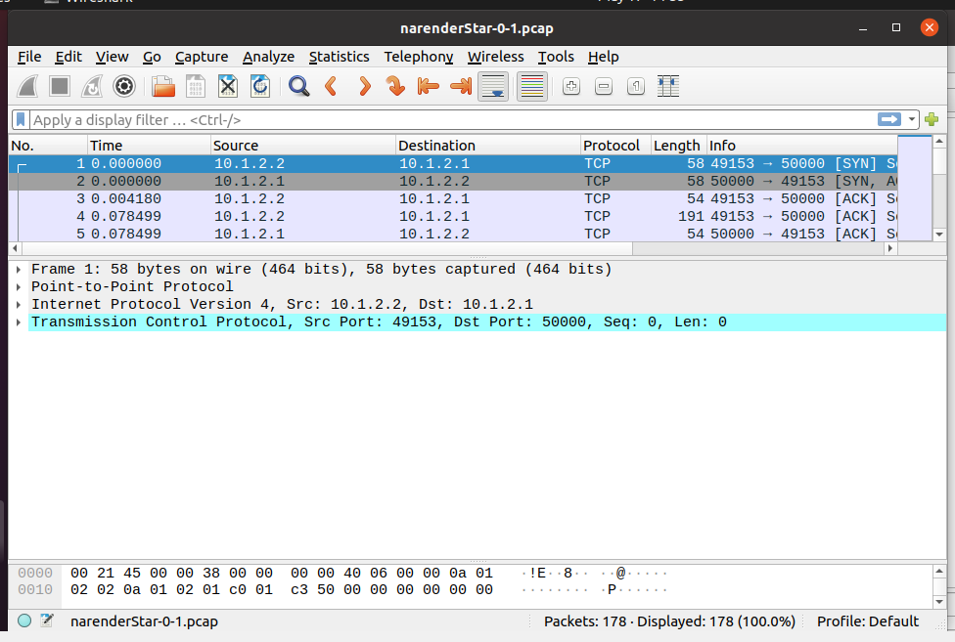

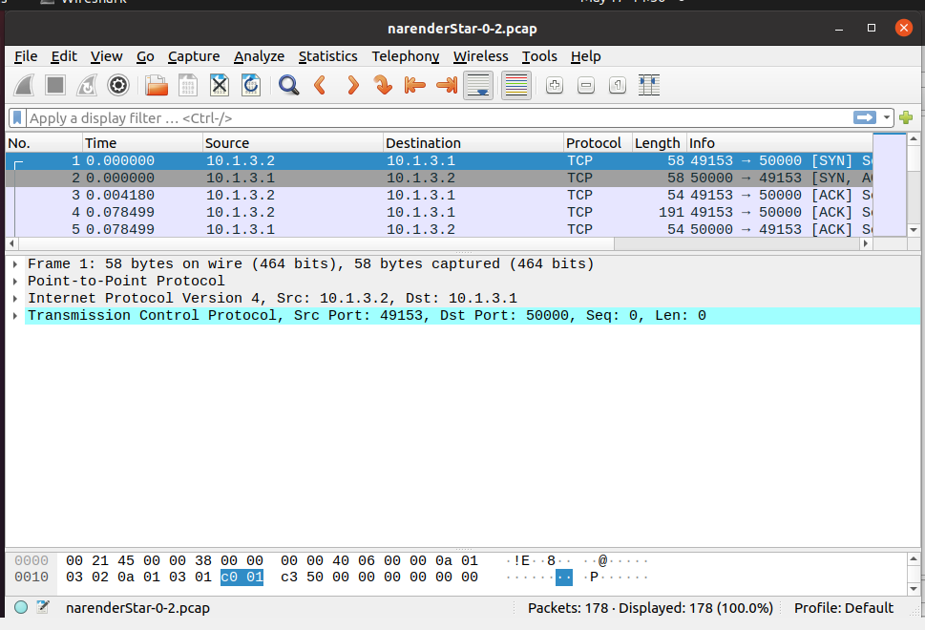

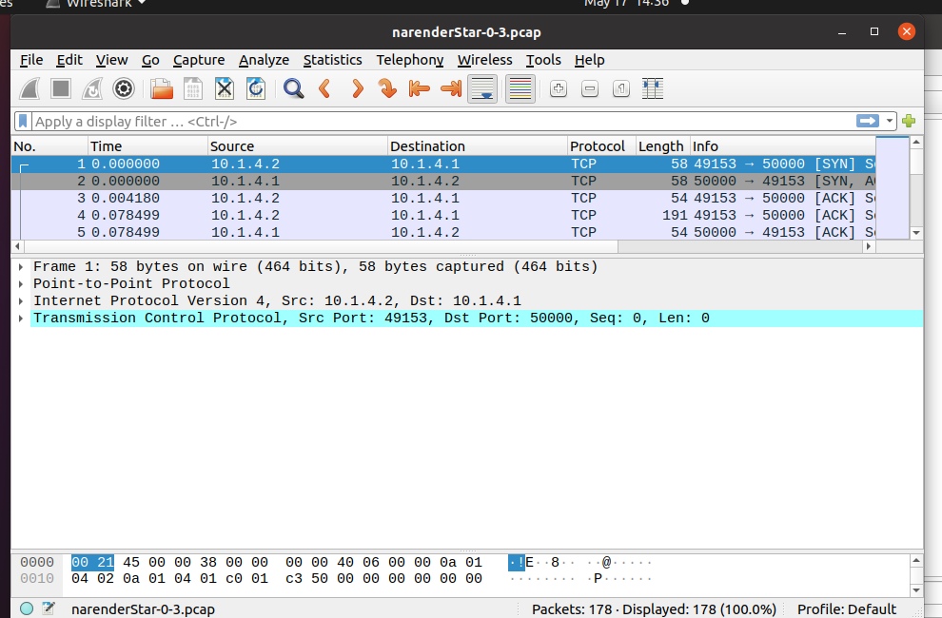

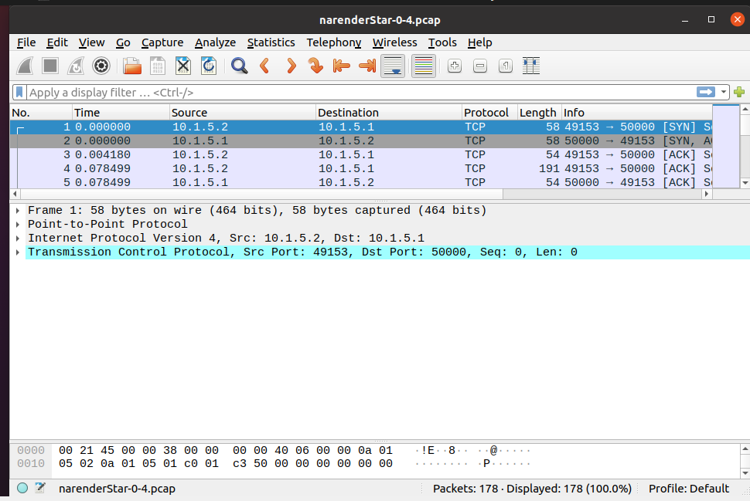

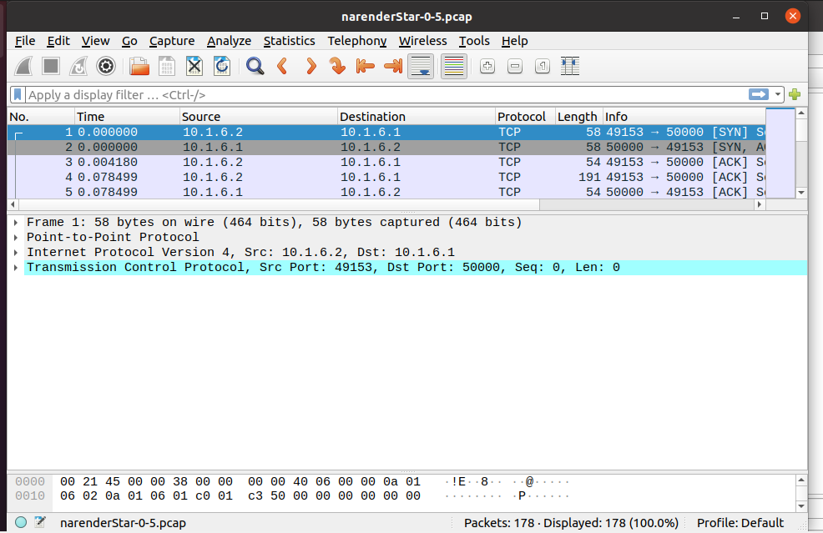

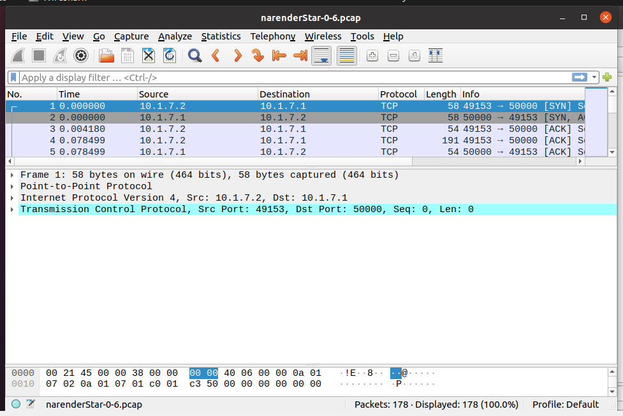

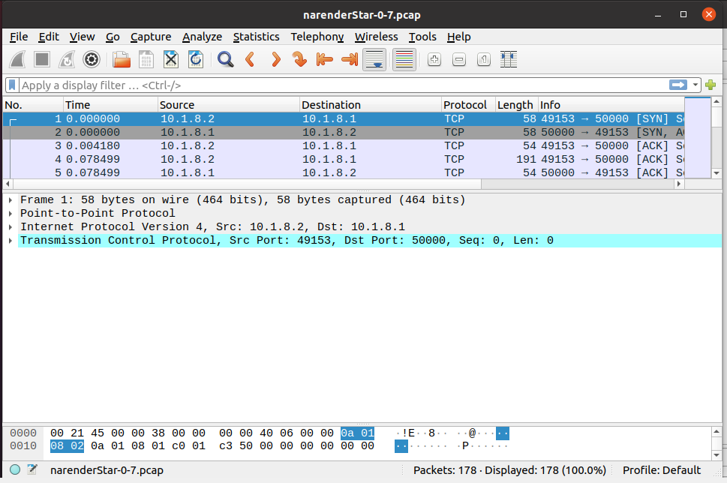

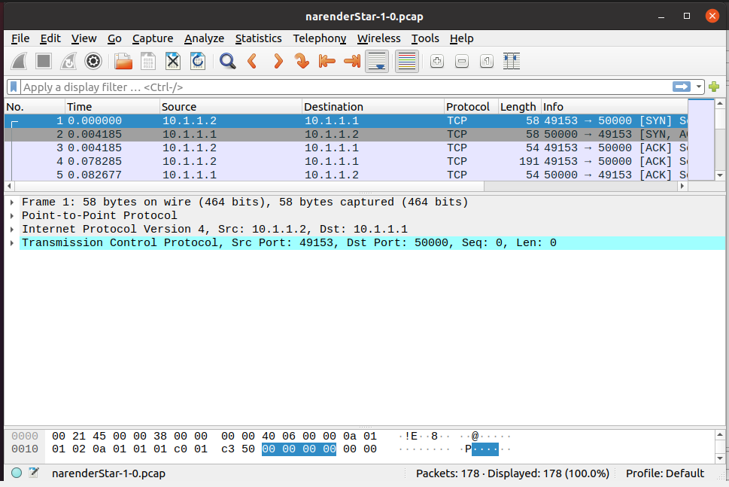

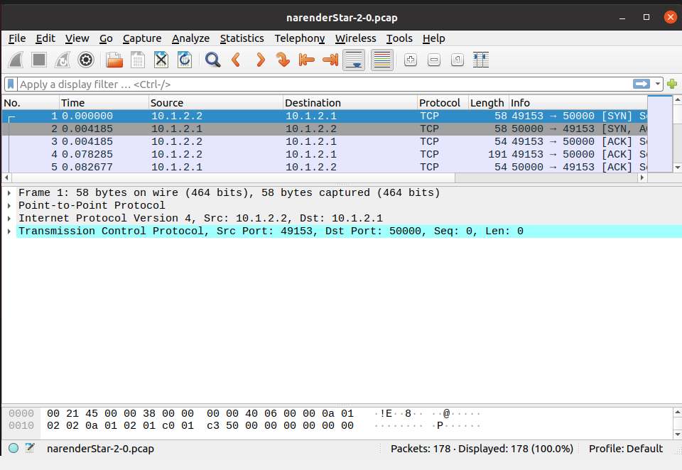

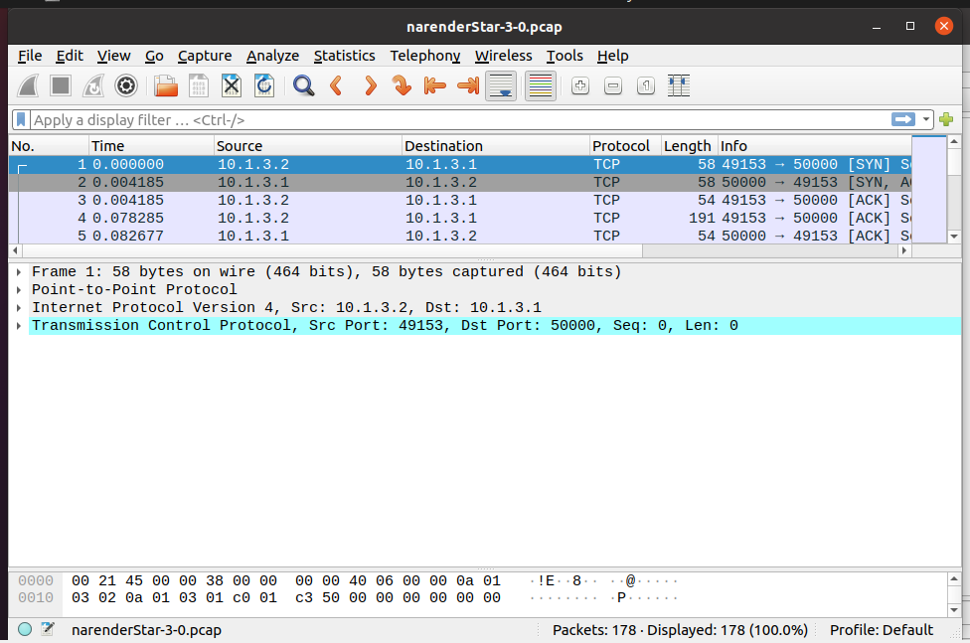

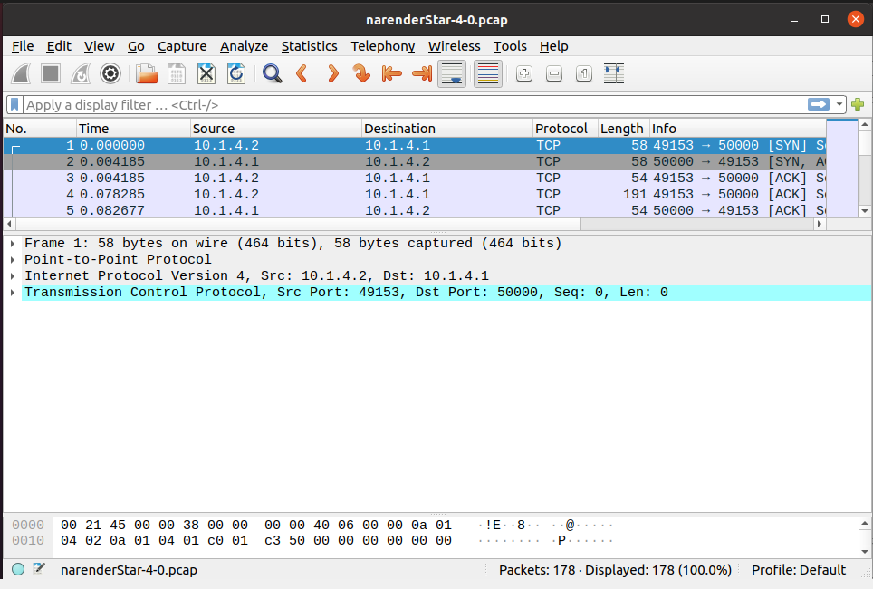

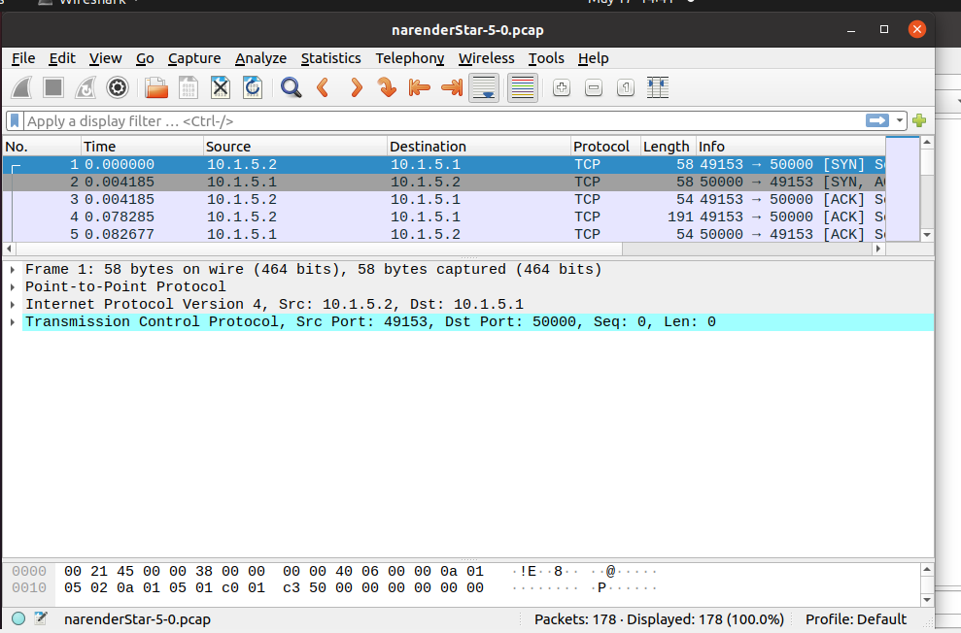

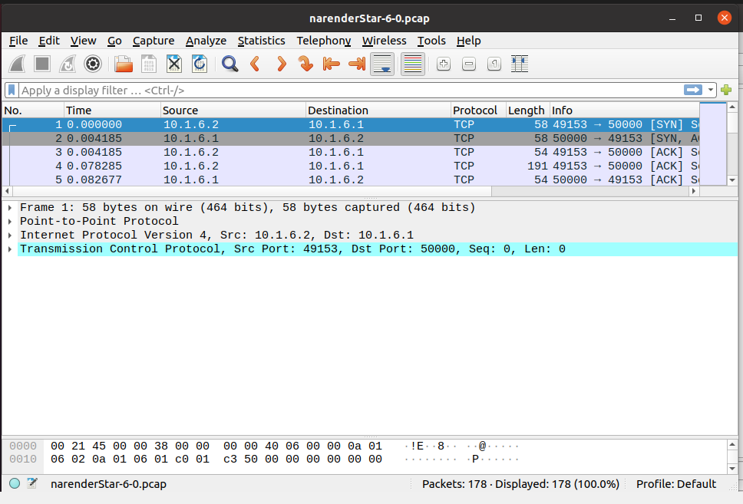

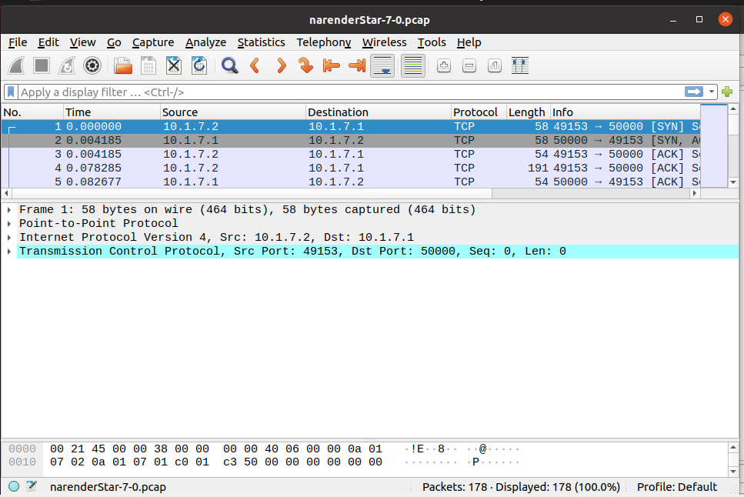

**CONCLUSION:**

From this practical, I have learned about star topology simulation in ns3.